C Program to Construct an Annotated Parse Tree and Evaluate an Arithmetic Expression.
AIM:
To write a C program to construct an annotated parse tree using the given grammar and evaluate the arithmetic expression.
PSEUDOCODE:
- Start the program.
- Read two numbers from the user.
- Perform addition of the two numbers.
- Construct the annotated parse tree using the grammar:
E → E + T
E → T
T → num
- Display the annotated parse tree with values.
- Display the evaluated result.
- Stop the program.

PROGRAM:
#include <stdio.h>

int main()
{
int a, b, result;

printf("Enter two numbers: ");
scanf("%d %d", &a, &b);

result = a + b;

printf("\nAnnotated Parse Tree:\n");
printf(" E (%d)\n", result);
printf(" / | \\\n");
printf(" E (%d) + T (%d)\n", a, b);
printf(" | |\n");
printf(" T (%d) num (%d)\n", a, b);
printf(" |\n");
printf(" num (%d)\n", a);

printf("\nEvaluated Result = %d\n", result);

return 0;
}
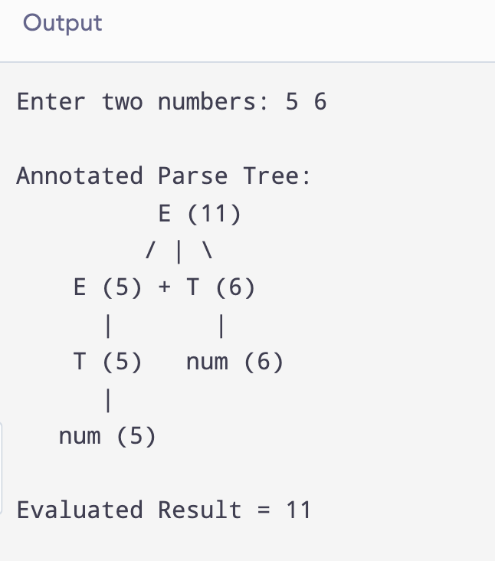

OUTPUT:

RESULT:
Thus, the C program to construct an annotated parse tree and evaluate the given arithmetic expression was successfully executed.

